WOMEN IN BUSINESS

GROWING THROUGH OPPORTUNITIES
June 25, 2015 – Madison WI

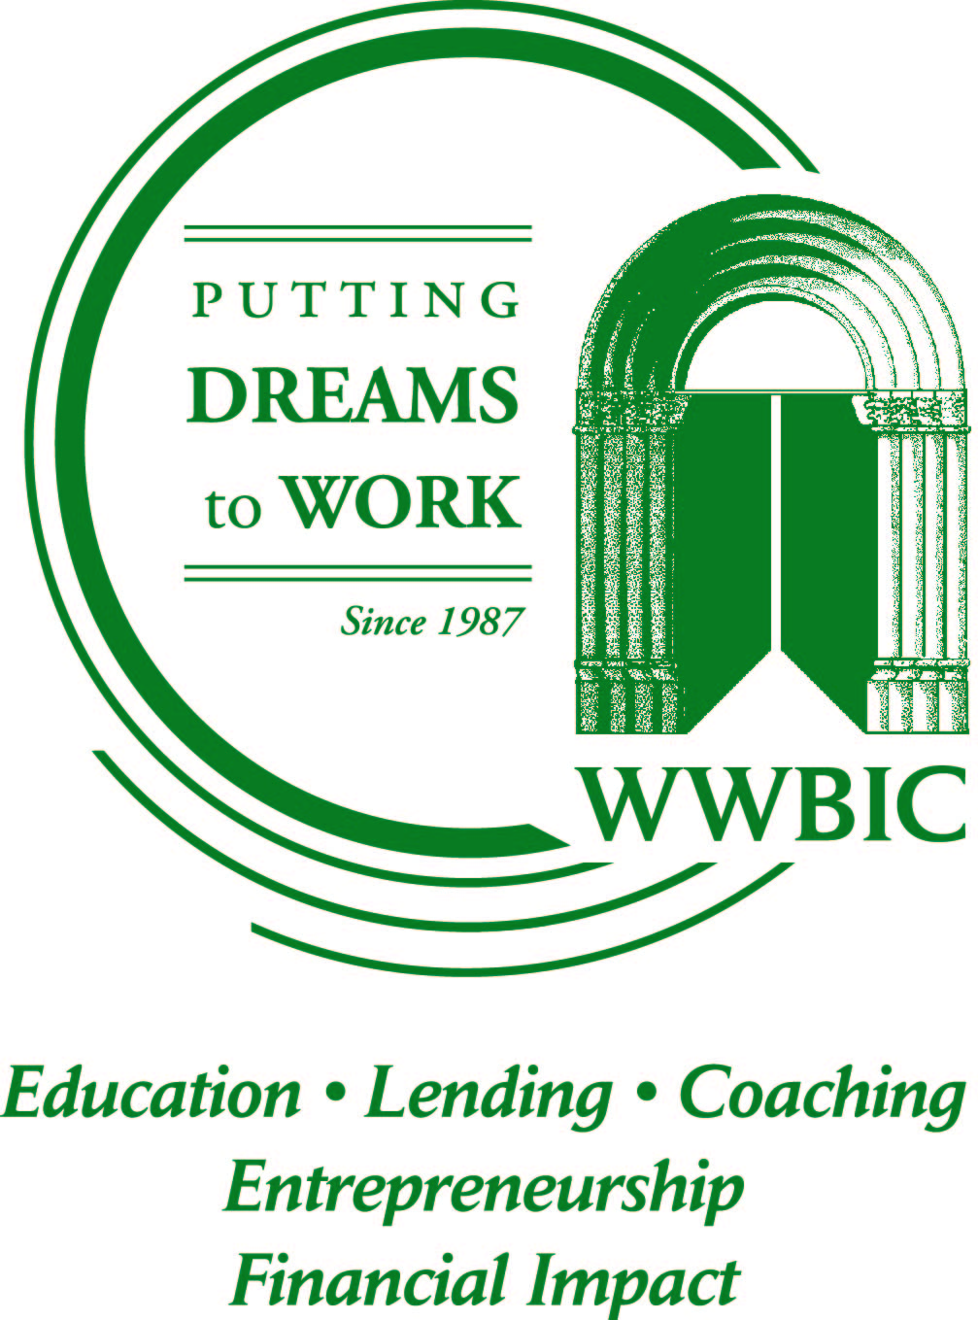

Hosted, Sponsored, and Presented by
Heartland Information Research (HIR)
US Small Business Administration (SBA)
Wisconsin Procurement Institute (WPI)
Wisconsin Women’s Business Initiative Corporation (WWBIC)

AGENDA
8:30 am – 9:00 am Registration

9:00 am – 9:15 am Welcome and introductions

9:15 am – 9:45 am Benefits of Woman Owned Small Business (WOSBC) Certification when Selling to Federal, State, Local Governments or Large Prime Contractors – presented by Kate Hill, Heartland Information Research (HIR) and Mary Trimmier, US Small Business Administration (US SBA)

9:45 am – 10:30 am Basics of Entering the Government Market – presented by Kim Garber, Wisconsin Procurement Institute

10:30 am – 10:45 am BREAK

10:45 am – 11:10 am Developing your Financial and Business Capabilities and Capacity – presented by Andrea Hughes, WWBIC

11:10 am – 11:30 am Panel Discussion by Successful Woman Owned Firms – moderated by Wisconsin Procurement Institute (WPI)
- Kate Hill - Heartland Information Research (HIR) – A research and management consulting firm that serves government agencies, businesses, and nonprofits.
- Cynthia Jansen Everhart – Energy Tech Solutions, LLC – A lighting firm providing a comprehensive, hand-selected suite of LED lighting products for sale with experience and technical knowledge to back it up.
- Kim Lobdell – KL Engineering – An Engineering firm providing professional services built around a core specialization in transportation engineering and an unwavering customer service ethic.
11:30 am – 12:00 pm Networking

