
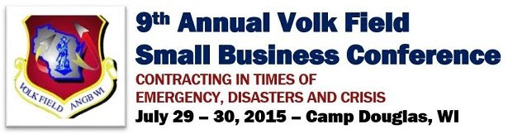

Congratulations to the 9th Annual Volk Field Small Business Conference Competition Winners!

Capabilities Statement Award Winners
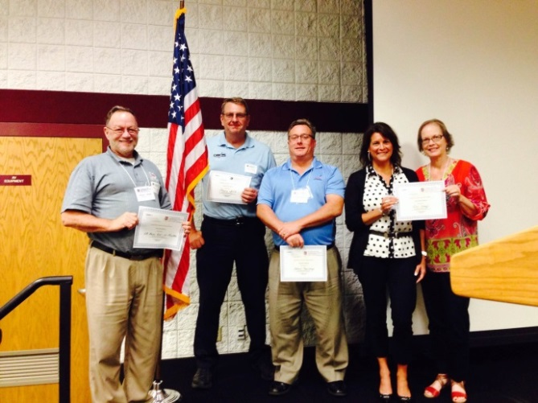

(From left: William Mielke, Mike Schmeling, Kevin McDermott, Carla Kutsche, Marcia Christy)

1st Place – HB Laser Art, Kenosha – presented by William Mielke and Steve Deringer
HB Laser Art genuinely wants to help award and recognize individuals within organizations with items that will bring lasting memories for the people involved. As a business, HB Laser Art is constantly striving for the highest quality, and unique awards in the industry with a wide variety of options available, timely delivery, and in house design, fabrication, and assembly. HB Laser Art is a certified Veteran Owned and Disabled Veteran Owned Business that has consistently grown to establish itself as an industry leader in the area and as a supplier of outstanding awards to the local community. Contact William Mielke, Owner/Project Manager at 262-671-4111 or visit www.laserartusa.com for more information.

Co - 2nd Place – Patriot Taxiway Industries, Lomira – presented by Kevin McDermott
Patriot Taxiway Industries is an award winning lighting solutions provider with a mission to provide superior quality aerospace and military lighting products and services to its customers through leadership, innovation and partnerships. As a Service Disabled Veteran Owned Small Business (SDVOSB), Patriot Taxiway Industries is unique in that they bring practical knowledge in lighting design and operational military aviation experience to provide expertise in developing, manufacturing and supporting their products. Contact Kevin McDermott, Vice President, Business Development at 414-688-7276 or visit www.patriottaxiway.com for more information.

Co - 2nd Place – The Geo Group Corporation, Madison – presented by Marcia Christy and Carla Kutsche
The GEO Group, Inc. (GEO) is the world's leading provider of correctional, detention, and community reentry services with 106 facilities, approximately 85,500 beds, and 20,000 employees around the globe. GEO is the first fully-integrated equity real estate investment trust specializing in the design, development, financing, and operation of correctional, detention, and community reentry facilities worldwide. Contact Goergia Roeming, President at 608-230-1010 or visit www.thegeogroup.com for more information.

3rd Place – Phoenix International, LTD., Brookfield – presented by Karen Schmeling and Mike Schmeling
Phoenix International Ltd. realized decades ago that stopping high-speed chases is a dangerous operation for law enforcement. In 1986, Phoenix International was the first manufacturer to introduce tire deflation devices to the U.S. market and demonstrate the effectiveness of tire spikes as a public safety tool. MagnumSpike!™ is an effective tire spike system for tire deflation with a 100% record of safe, successful vehicle stops. Contact Adi Dohndy, Operations Director at 262-784-2732 or visit www.magnumspike.com for more information.
2 Minutes to Win It Award Winners
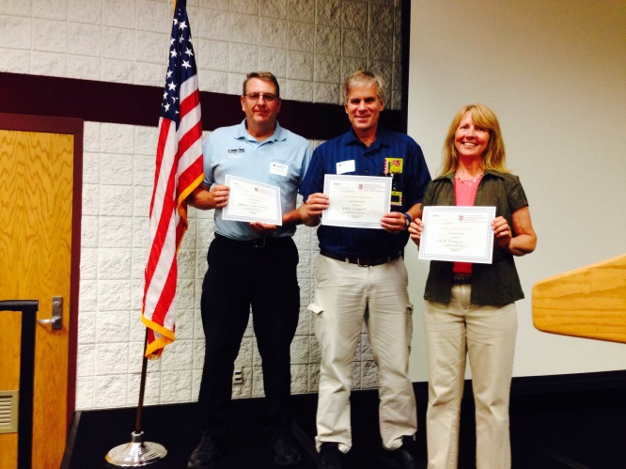

(From left: Mike Schmeling, Gary Krause, Michelle Rasmussen)

1st Place – Phoenix International, LTD., Brookfield – presented by Mike Schmeling and Karen Schmeling
Phoenix International Ltd. realized decades ago that stopping high-speed chases is a dangerous operation for law enforcement. In 1986, Phoenix International was the first manufacturer to introduce tire deflation devices to the U.S. market and demonstrate the effectiveness of tire spikes as a public safety tool. MagnumSpike!™ is an effective tire spike system for tire deflation with a 100% record of safe, successful vehicle stops. Contact Adi Dohndy, Operations Director at 262-784-2732 or visit www.magnumspike.com for more information.

2nd Place – EKG Concepts, Racine – presented by Gary Krause
EKG Concepts has developed Rapid Cardiac Analysis Tools that help medical personnel accurately and rapidly identify 41 different EKG Rhythms and 12 lead EKG changes associated with Ischemia, Injury, and Infarction. This allows medical personnel to initiate proper treatment, save valuable time, reduce critical errors, and improve patient outcomes using these tools to assist in rapid rhythm interpretation or early detection of myocardial injury. Contact Gary Krause, Owner at 262-498-5047 or visit www.ekgconcepts.com for more information.

3rd Place – MLR Products, Tomah – presented by Michelle Rasmussen
MLR Products is a Woman Owned Small Business that provides creative products for the home and property owners to help keep America beautiful. MLR Products offers cost-effective tools and products to organize necessary home and property items. MLR Products provides practical solutions to secure recycling bins to the yard, will be offering attractive signs to attach to the stake, and creating tools to meet needs with innovative solutions. Contact Michelle Rasmussen, CEO/Owner at 608-343-3605 or visit www.mlrproducts.com for more information.
A Special Thanks to our Judges for both the Capabilities Statement Competition and the 2 Minutes to Win It Competition!
William Capelle - American Pride Industrial Equipment and Services
Frank Demarest - US Small Business Administration
Ken Maciejewski - Opportunities Inc.
Daryl Zahn – DRS Power & Control Technologies Inc.
Kate Hill – Heartland Information Research
Karman Briggs and Ken Pearson - Western Dairyland Economic Opportunity Council

