The news coverage of Hurricane Harvey has clearly shown the significant impact a natural disaster can have upon our infrastructure, businesses and homes. FEMA’s Daily Operations Briefing for August 29, 2017 provides an Analysis of Impacts of the storm and this summary level information provides a glimpse to the level of impact and a hint of the types of assistance - goods and services that may be required to assist this region with the immediate needs but also to assist with recovery efforts.
Analysis of Impacts
Evacuations:
•TX -mandatory evacuations for 726k people with voluntary evacuations for over one million people
•LA -mandatory evacuations for 6k with voluntary evacuations for 133kpeople
•Modeling projections estimate 67k residential homes affected with 5.5k with major damage across 16 counties in TX
•Power outages: 268k customers without power in TX* (DOE Eagle-I as of 7:30 am EDT).
•Shelters/occupants: 100 / 6k in TX and 1 / 20 in LA (ESF #6 as of 2:00 pm EDT, August 28)

However, as shown in the following national map, Hurricane Harvey is just one of many disasters which are currently being managed and for which various products and services may be needed.
Additional information related to major disaster declarations and emergency declarations are published in the Federal Register and are available at http://www.fema.gov/news/disasters.fema.

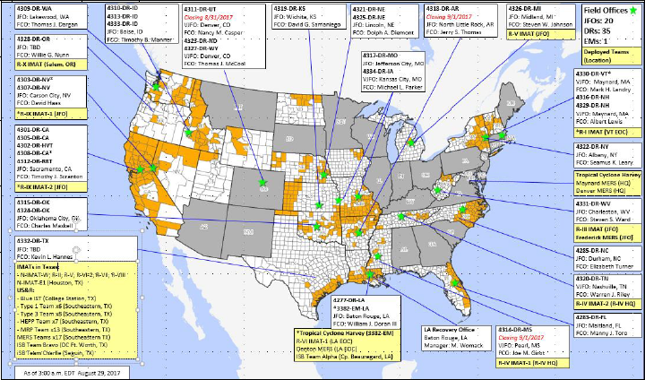
Figure 1 FEMA Daily Operations Briefing for August 29, 2017, Locations with Disaster Declarations
Companies that would like to assist with recovery efforts can do so by reviewing their SAM Registration and insuring that they have selected the option to be included in the National Disaster Registry. As required by FAR 26.205, Contracting officers shall consult the Disaster Response Registry via https://www.acquisition.gov/disaster-response-registry to determine the availability of contractors for debris removal, distribution of supplies, reconstruction, and other disaster or emergency relief activities inside the United States and outlying areas.
Companies should also determine if there are any additional registration that may be beneficial as indicated by the following item copied from the State of Texas Situation Report for August 28, 2017.
Texas Comptroller of Public Accounts (CPA): Issuing purchase orders in response to requests. Assisting in locating vendors for needed supplies and equipment. ---page 13 of 16, State Situation Report #6, August 28, 2017.
Companies that hold GSA Schedule contracts should not only verify that they have made the appropriate selection in their SAM Registration, they should also review their contract to insure that they have selected to participate in GSA’s Disaster and Recovery Purchasing program. See the following web page for additional information - www.gsa.gov/disasterpurchasing
Action – If you have not made this selection but would like to make a change, contact your Administrative Contracting Officer to make the change.
Orders under this program can be placed using any of the GSA Schedules. Additionally, State and Local Governments can use credit cards to make purchases. They also can make purchases from the GSA Advantage portal and they can also use the GSA eBuy system.
Please note: If you receive orders, insure that the following mandatory language is included -
This order is placed under GSA Schedule number "insert number here" under the authority of the GSA Disaster Purchasing program. The products and services purchased will be used in preparation or response to disasters or recovery from major disaster declared by the President, or recovery from terrorism or nuclear, biological, chemical, or radiological attack.

